Project Report On

Online Shopping System

Submitted By

Neha Singh

Under the guidance of

Mrs. Vimala Rani R

Submitted in partial fulfilment of the requirement

for qualifying T.Y.B.Sc. Computer Science

Semester VI Examination

March 2018

DEPARTMENT OF COMPUTER SCIENCE

KISHINCHAND CHELLARAM COLLEGE

Churchgate, Mumbai – 400 020



**Garment House**

Ladies Garment House

______________________________________________________

C/12 Veer Jijamata Nagar, Dr. E. Moses Road, Worli, Mumbai-400018.

Date:10/03/2018

**TO WHOMSOEVER MAY IT CONCERNS**

This is to inform that we are granting **MS. Neha Singh,** student of TYBSc Computer Science of K. C. College to develop a website application on our Garment House.

We hereby hope that her website application will be beneficial in making our management more efficient.

**THANKING YOU.**

**Yours Faithfully,**

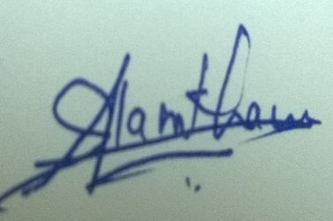

**Authorized Signatory**

**Date: 20/03/2018**

**TO WHOMSOEVER IT MAY CONCERN**

This is to certify that **Ms. Neha Singh**, a student of KC College, TYBSc Computer Science has successfully completed her project titled “**Garment House**”, **Website application** for our company **“Garment House”** boutique, with reference to the partial fulfillment of the requirements of the BSc Computer Science Course, University of Mumbai.

All necessary details were provided from our side for the establishment of this project.

We wish her the very best in all her future endeavors.

Thanking You.

With Regards

For **Garment House**

Head/Co-ordinator/Proprietor



**ACKNOWLEDGEMENT**

Foremost, I thank the Almighty for showering his blessings upon me. This research would not have been possible without his grace. Every project big or small is successful largely due to the effort of a number of wonderful people who have always given their valuable advice or lent a helping hand. I sincerely appreciate the inspiration; support and guidance of all those people who have been instrumental in making this project a success.

I wish to express a sense of gratitude towards my beloved parents, my siblings for their encouragement, constant help and support throughout.

I would like to express my deep regards to Dr. Hemlata Bagla, Principal of K. C. College for providing me with the facilities of the institution.

Similarly, I thank our Vice Principal Dr.Shalini Sinha, Head of the Department of Computer Science for being a constant source of inspiration and making all the necessary facilities available to me during my project formation.

With immense gratitude, I would like to give a very special honor and respect to my mentor Mrs.Vimala Rani R who took keen interest in checking the minute details of the project work and guided us throughout the same. Her continuous support, patience, motivation, enthusiasm and immense knowledge not only helped in making my efforts fruitful but also transformed the whole process of learning and implementation into an enjoyable experience.

I am also pleased to thank other project guides and teachers, Mrs. Geeta Brijwani, Mr. Narendra Maurya, Mrs. Shalini Maheshgauri and Mr. Maunash Jani for their guidance and constant supervision as well as for providing necessary information regarding the project and also for their support in completing the project.

I am thankful to all the non-teaching staff of the computer science department for being so accommodating and co-operative all through.

Last but not the least, I wish express my gratitude to my friends and ex TY Students for their constant encouragement, support and for assisting me with their inputs.

**INDEX**

|  |  |
| --- | --- |
| **Topic** | **Page Number** |
| **I. Preliminary Investigation** |  |
| 1. Organizational Overview | 2 |
| 1. Description of the System | 3 |
| 1. Limitations of the present system | 4 |
| 1. Proposed system and its advantages | 5 |
| 1. Feasibility Study | 6 |
| 1. Stakeholders | 7 |
| 1. Technologies used | 6 |
| 1. Gantt Chart | 8-9 |
| **II. System Analysis** |  |
| 1. Fact Finding Techniques | 11 |
| 1. Event Table | 12-14 |
| 1. Use Case Diagram, Scenarios and Use case description | 15-18 |
| 1. ERD | 19 |
| 1. Activity Diagram | 21-22 |
| 1. Class Diagram | 20 |
| 1. Object Diagram |  |
| 1. Sequence Diagram / Collaboration Diagram | 25-26 |
| 1. State Diagram | 23-24 |

|  |  |
| --- | --- |
| **Topic** | **Page Number** |
| **III. System Design** |  |
| 1. Converting ERD to Tables | 28-31 |
| 1. Design Class Diagram | 32-33 |
| 1. Component Diagram | 34 |
| 1. Package Diagram |  |
| 1. Deployment Diagram | 35 |
| **IV. System Coding** |  |
| 1. Menu Tree / Sitemap | 37 |
| 1. List of tables with attributes and constraints | 38-41 |
| 1. Design patterns used |  |
| 1. Program Description with Naming Conventions | 42 |
| 1. Validations | 43 |
| 1. Test Cases, Test Data and Test Results |  |
| 1. Screen Layouts and Report Layouts | 44-49 |
| 1. Program Listing | 50 |
| **V. System Implementation and Uploading** | 51 |
| **VI. Future Enhancements** | 52 |
| **VII. Reference and Bibliography** | 53 |

PRELIMINARY INVESTIGATION

**Organization Overview**

**Garment House** is a boutique situated on Dr. E. Moses Road in Mumbai by **“Mr.** **Mohammed Aslam Khan”** since the year 2005. He has worked before in the country of Saudi Arabia and Bahrain for 17 years in the field of fashion world. He has created many dresses for many people.

The boutique takes orders for dresses and also place customized orders and the same are delivered to the customers.

**Description of Present overview:**

The present system works by placing orders via calls and home visit to the clients. The transactions are done manually and reports are kept written in books and often after the year ends the books are discarded and new books are filled with order details and transaction details, etc.

No stock records are kept. No client order summary is maintained.

The present system has many faults which are hard to track and maintain. It gets tiresome to deliver the orders on time due to this system. Sometime the orders are cancelled due to delay in delivery

**LIMITATIONS OF THE PRESENT SYSTEM**

* The Garment House is only for women’s not for the men’s.
* The current system does not provide any online transaction.
* In the current system only, cash on delivery and cheque are available for the payment

**PROPOSED SYSTEM & ITS ADVANTAGES**

* This system will automate the process of storing and viewing the information of customer’s who ordering the product.
* Whatever be the cloth which is left after making the product will return back to the customer.
* If the customer’s wants to collect their product from our store they can otherwise there will be a home delivery also.
* All the payment record will be maintaining in a register so that after the completion of delivery the amount will be in our hand.
* There will be no delay in the delivery.
* Data can be safely maintained on a separate server.

Computerized system will help in storing large amount of data

**Feasibility Study**

The project feasibility is concerned with expected benefits. An important outcome of the preliminary investigation is the destination that the proposed system is feasible.

**Technical Feasibility:**

**Technology used:**

* **MYSQL**

MYSQL is a popular choice of database for use in web applications and is a central component of the widely used LAMP open source web application software stack (and other AMP’s stacks).

* **Language: PHP**

PHP allows a static web page to become dynamic. PHP is acronym that stands for “PHP: Hypertext Pre-processor.”

* **BACK-END: PHP MyAdmin**

PHP MyAdmin is a free software tool written in php, intended to handle the administration of MYSQL over the web.

**Organizational and cultural Feasibility:**

As the system is quite user-friendly and the GUI is fairly simple, the users should find it easy to handle the system and there will be hardly any problem in adapting the new system

**Stake Holders**

**Admin**

Admin can add/update/remove customers, designs, custom designs and it can view records of customers and can give the delivery report.

**Customer**

Customer can register/login/add/order/customize/delete herself, designs to wishlist, place an order, customize order and can delete an account from the website.

**GANTT CHART 2016-2017**

|  |  |  |
| --- | --- | --- |
| **Topic** | **Proposed Dates** | **Actual Dates** |
| **I. Preliminary Investigation** | **24th Nov 2017** | **27th Nov 2017** |
| (i) Organizational Overview | **24th Nov 2017** | **27th Nov 2017** |
| (ii) Description of System | **24th Nov 2017** | **27th Nov 2017** |
| (iii) Limitations of present system | **24th Nov 2017** | **27th Nov 2017** |
| (iv) Proposed system and its Advantages | **24th Nov 2017** | **27th Nov 2017** |
| (v) Feasibility Study | **24th Nov 2017** | **27th Nov 2017** |
| (vi) Stakeholders | **24th Nov 2017** | **27th Nov 2017** |
| (vi) Gantt Chart |  |  |
|  |  |  |
| **II. System Analysis** | **15th Dec 2017** | **18th Dec 2017** |
| (i) Fact Finding Techniques | **8th Dec 2017** | **18th Dec 2017** |
| (ii) Event Table | **8th Dec 2017** | **18th Dec 2017** |
| (iii) Use Case Diagram, Scenarios &  Use Case Description | **12th Dec 2017** | **18th Dec 2017** |
| (iv) ERD | **12th Dec 2017** | **18th Dec 2017** |
| (v) Activity Diagram | **14th Dec 2017** | **18th Dec 2017** |
| (vi) Class Diagram | **8th Dec 2017** | **18th Dec 2017** |
| (vii) Object Diagram | **15th Dec 2017** | **18th Dec 2017** |
| (viii) Sequence Diagram | **15th Dec 2017** | **18th Dec 2017** |
| (ix) State Diagram | **15th Dec 2017** | **18th Dec 2017** |
| **III. System Design** | **22nd Dec 2017** | **2nd Jan 2018** |
| (i) Converting ERD to Tables | 22nd Dec 2017 | **2nd Jan 2018** |

|  |  |  |
| --- | --- | --- |
| Topic | Proposed Dates | **Actual Dates** |
| (ii) Design Class Diagram | 22nd Dec 2017 | **2nd Jan 2018** |
| (iii) Component Diagram | 22nd Dec 2017 | **2nd Jan 2018** |
| (iv) Package Diagram | 22nd Dec 2017 | **2nd Jan 2018** |
| (v)Deployment Diagram | 22nd Dec 2017 | **2nd Jan 2018** |
|  |  |  |
| **IV. System Coding** | 23rd Jan 2018 | **9th Feb 2018** |
| (i) Menu Tree / Sitemap | 23rd Jan 2018 | **9th Feb 2018** |
| (ii) List of tables with attributes and constraints | 23rd Jan 2018 | **9th Feb 2018** |
| (iii) Program Description with Naming Conventions | 23rd Jan 2018 | **9th Feb 2018** |
| (iv) Validations | 23rd Jan 2018 | **9th Feb 2018** |
| (v) Test Cases, Test Data and Test Results | 23rd Jan 2018 | **9th Feb 2018** |
| (vi) Screen Layouts & Report Layouts | 23rd Jan 2018 | **9th Feb 2018** |
| (vii) Program Listing | 23rd Jan 2018 | **9th Feb 2018** |
|  |  |  |
| **V. System Implementation / Uploading** | **25th Jan 2018** | **10th Feb 2018** |
| **VI. Future Enhancements** |  | **12th Feb 2018** |

SYSTEM ANALYSIS

**FACT FINDING TECHNIQUES**

Before developing the web-application, a detailed information required regarding the working of the current system and the needs of the client. This Information was gathered by visiting the Garment House boutique and understanding the entire work process of storing and accessing the data of every customer, by understanding the flexibility of notifying the customer about the customize design’s delivery of the product.

**Questionnaire:**

* How do you currently store data of customers?
* What problems do you face in the current storage system?
* Is product delivery on manual calls simpler or would you prefer an automated system.
* What is the process of storing all this data?
* How does customer track their product delivery?
* How do you notify customer regarding product delivery?

**Event List**

* Customer registers
* Customer wants to login
* Customer want to add design to wish list
* Customer want to place an order
* Customer want the delivery report of the product
* Customer want to customize an order
* Customer want to delete an account
* Admin wants to login
* Admin adds new customer
* Admin view customer
* Admin update designs
* Admin update custom design, cloth, color
* Admin remove the design
* Admin remove customize design, cloth, color

**Temporal Events**

* Time to produce delivery report of product.

**Event Table:**

|  |  |  |  |  |  |  |
| --- | --- | --- | --- | --- | --- | --- |
| **Sr.No** | **Event** | **Trigger** | **Source** | **Activity** | **Response** | **Destination** |
| 1. | Customer wants to register on website. | Checking whether customer exists or not. |  | New customer record if the customer doesn’t exists. | Validate and update detail. | Customer table. |
| 2. | Customer adds design to wishlist. | Wishlist id is generated. | Client table. | Add the design to wishlist. | Stores the design in customer wishlist. | Wishlist table. |
| 3. | Customer wants to place an order. | Order id is generated. | Client table. | Add the order. | Stores order details. | Orders table and order details. |
| 4. | Generating delivery date and order cost. | Cost is calculated and delivery date is set. | Client table. | Check the availability details for delivery. | Generating report. | Orders table and orders detail table. |
| 5. | Customer wants to Customize the order. | Checking whether customization is available or not. | Client table. | New Customized order is generated. | Validate and Update order. | Customer order table. |
| 6. | Customer wants to delete its account from the website | Check whether deletion of account is possible or not. | Client table. | Delete the account of customer from the table. | Validate and update the account. | Client table. |
| 7. | Administrator wants to add new customer. | Checking whether the customer exits or not |  | New customer record is added if the customer doesn’t exist. | Validate and update the design. | Client table. |
| 8. | Administrator wants to add new design. | New product id is generated. | Admin table. | New design is added if the design doesn’t exists. | Validate and update design. | Product table. |
| 9. | Administrator wants to add new custom design,cloth,color. | New custom design id is generated. | Admin table. | New custom design,cloth,color is added if the design,cloth,color is not generated. | Validate and update the design. | Custom design table. |
| 10. | Administrator wants to remove design. | Check whether the design can be removed or not. | Product table. | Delete the design from the product table. | Validate and update the design. | Product table. |
| 11. | Administrator wants to remove the customize design,cloth,color. | Checks whether the customized design,cloth,color can be removed or not. | Custom design table. | Delete the design,cloth,color from the custom design table. | Validate and update the custom design table. | Custom design table. |

**USE CASE DESCRIPTION**

**Actor:**

* Actor is a user of the system
* Actor can be human being, a machine, or a software.
* Actor is a role that a particular user plays while interacting with the system.

**Use cases:**

* Use cases are services or function provided by the system to its users.
* A Use Case is the set of activities performed within a System by a user.
* Each use case describes one logical interaction between the Actor & System.

**Roles of Actors:**

* Customer:
  + Customer can log in using Email-Id and Password.
  + Customer can add the design to the wish list.
  + Customer can place an order.
  + Customer can have detailed delivery report of the product.
  + Customer can customize an order.
  + Customer can delete an account.
* Admin
  + Admin can add customer.
  + Admin can update new designs.
  + Admin can update new custom design, cloth and color.
  + Admin can remove the design.
  + Admin can remove the customize design, cloth and color.

**Use Case Diagram:**

**Customer**

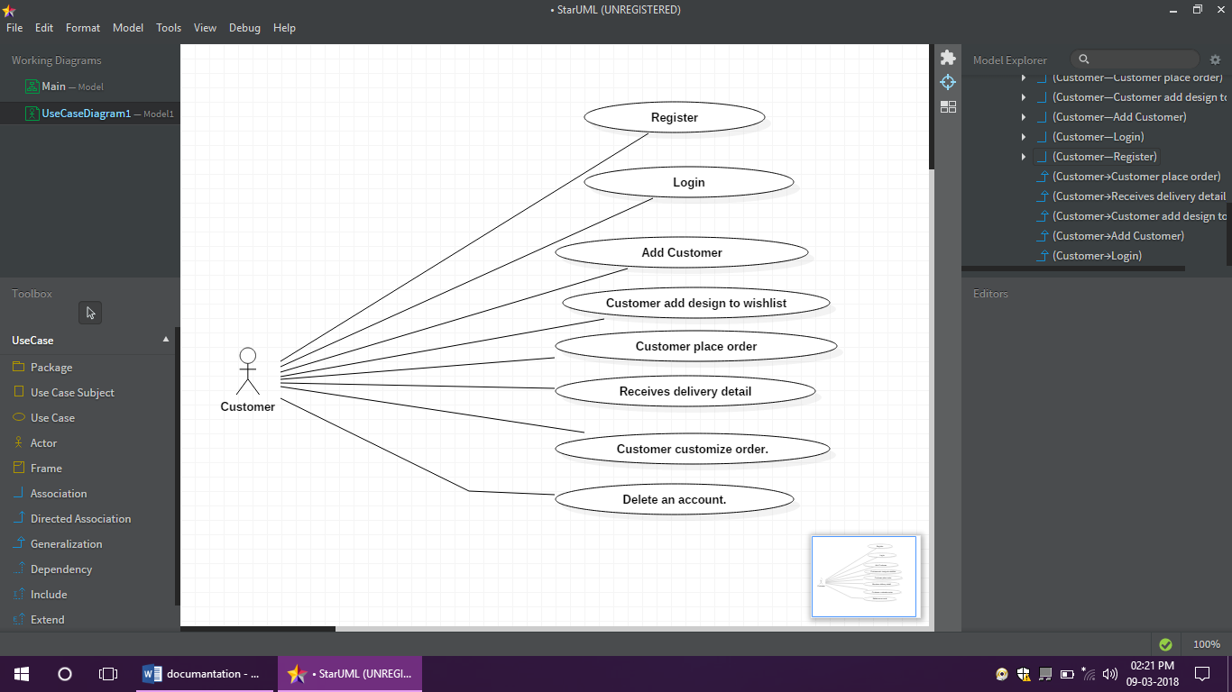

**Admin**

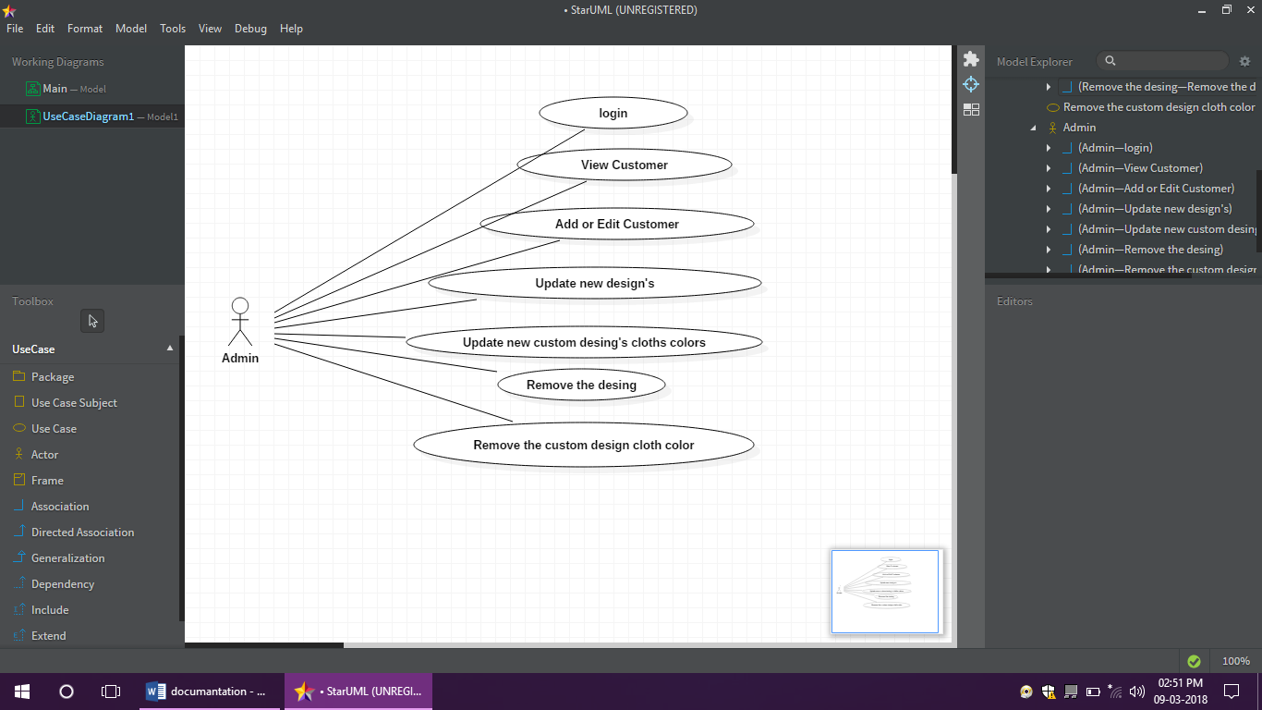

**ENTITY RELATIONSHIP DIAGRAM:**

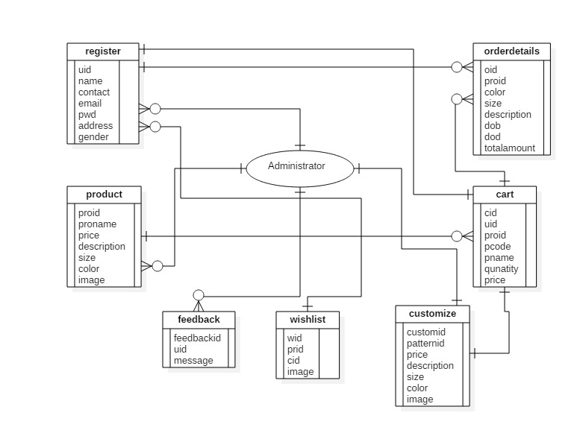

**CLASS DIAGRAM:**

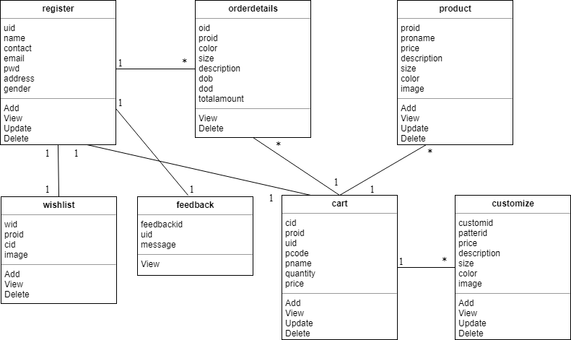

**ACTIVITY DIAGRAM:**

ADMIN:

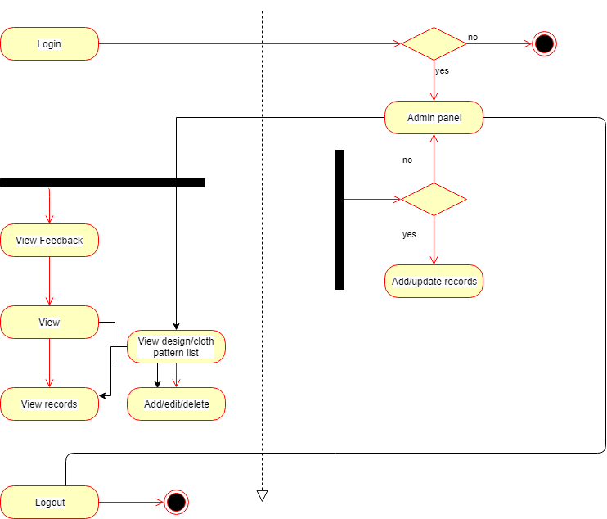

CUSTOMER:

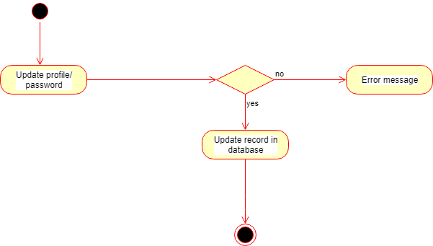

**STATE DIAGRAM:**

ADMIN:

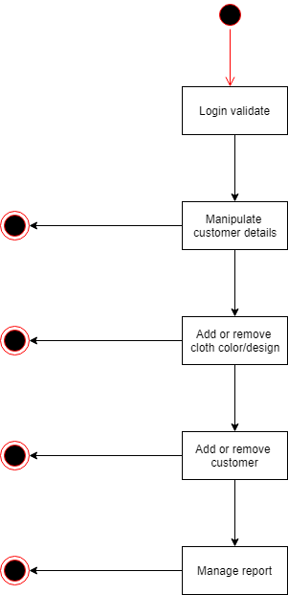

CUSTOMER**:**

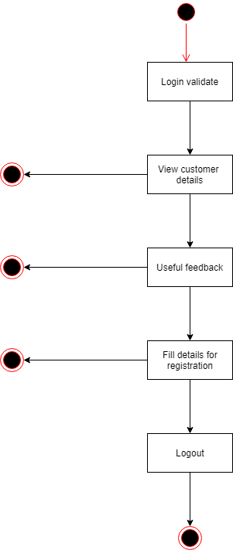

**SEQUENCE DIAGRAM:**

ADMIN:

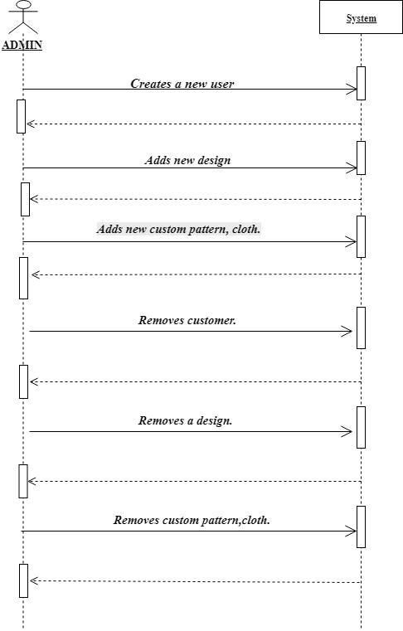

CUSTOMER:

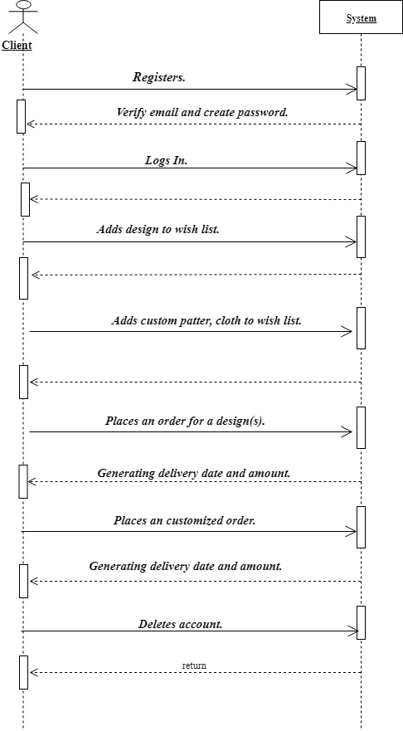

SYSTEM DESIGN

**CONVERTING ERD TO TABLES:**

## Register table:

|  |  |
| --- | --- |
| **Column** | **Type** |
| **uid** | **Int(11)** |
| name | Varchar(30) |
| Contact | int(30) |
| email | Varchar(30) |
| Pwd | Varchar(30) |
| address | Varchar(1000) |
| gender | Varchar(50) |

## Product table:

|  |  |
| --- | --- |
| **Column** | **Type** |
| **Proid** | int(30) |
| Proname | Varchar(30) |
| price | double |
| Description | text |
| Size | int(30) |
| Color | Varchar(30) |
| image | Varchar(200) |

## Customize table:

|  |  |
| --- | --- |
| **Column** | **Type** |
| **customid** | int(11) |
| patternid | int(11) |
| price | double |
| Description | text |
| Size | int(30) |
| Color | Varchar(30) |
| image | Varchar(200) |

**Orderdetails table:**

|  |  |
| --- | --- |
| **Column** | **Type** |
| **oid** | **Int(11)** |
| **Proid** | Varchar(30) |
| Color | Varchar(30) |
| Size | int(30) |
| Description | text |
| d.o.b | int(11) |
| d.o.d | Int(11) |
| totalamount | double |

**Wishlist table:**

|  |  |
| --- | --- |
| **Column** | **Type** |
| wid | int(11) |
| Proid | varchar(11) |
| cid | Int(11) |
| image | Varchar(200) |

## Cart table:

|  |  |
| --- | --- |
| **Column** | **Type** |
| **cid** | Int(11) |
| **uid** | Int(11) |
| **proid** | int(30) |
| **pcode** | varchar(30) |
| Pname | Varchar(30) |
| quantity | Int(30) |
| price | Varchar(300) |

## Feedback table:

|  |  |
| --- | --- |
| column | Type |
| feedbackid | int(11) |
| uid | Int(11) |
| message | text |

**DESIGN CLASS DIAGRAM:**

ADMIN:

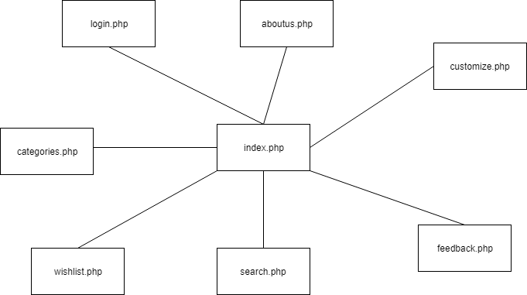

CUSTOMER:

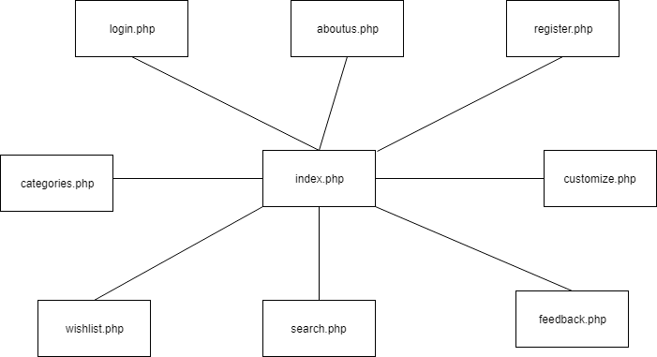

**COMPONENT DIAGRAM:**

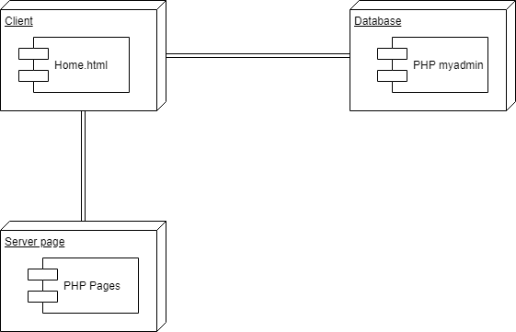

**DEPLOYEMENT DIAGRAM:**

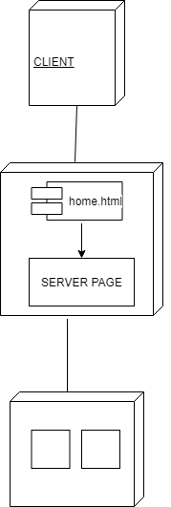

SYSTEM CODING

**MENU TREE/ SITE MAP:**

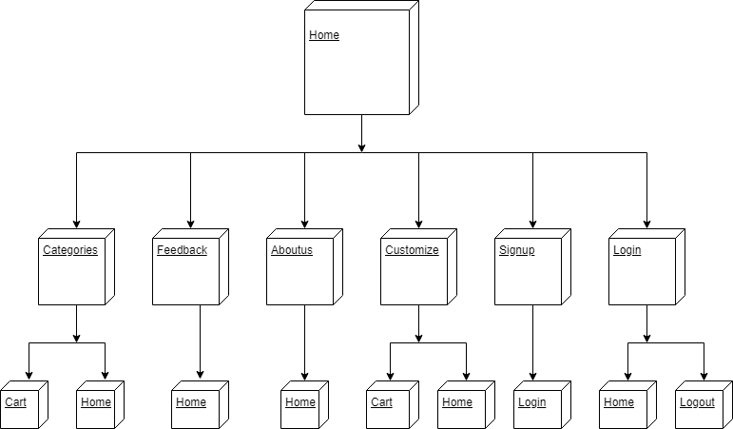

**LIST OF TABLES WITH ATTRIBUTES AND CONSTRAINTS**

**DATABASE: GARMENT HOUSE**

**TABLES:**

## Register table:

|  |  |  |  |
| --- | --- | --- | --- |
| **Column** | **Type** | **Null** | **Default** |
| **uid** | **Int(11)** | **No** | **Primary key** |
| name | Varchar(30) | Yes |  |
| Contact | int(30) | Yes |  |
| email | Varchar(30) | Yes |  |
| Pwd | Varchar(30) | Yes |  |
| address | Varchar(1000) | Yes |  |
| gender | Varchar(50) | Yes |  |

## Product table:

|  |  |  |  |
| --- | --- | --- | --- |
| **Column** | **Type** | **Null** | **Default** |
| **Proid** | int(30) | No | Primary_key |
| Proname | Varchar(30) | Yes |  |
| price | double | Yes |  |
| Description | text | Yes |  |
| Size | int(30) | Yes |  |
| Color | Varchar(30) | Yes |  |
| image | Varchar(200) | Yes |  |

## Customize:

|  |  |  |  |
| --- | --- | --- | --- |
| **Column** | **Type** | **Null** | **Default** |
| **customid** | int(11) | No | Primary_key |
| patternid | int(11) | Yes |  |
| price | double | Yes |  |
| Description | text | Yes |  |
| Size | int(30) | Yes |  |
| Color | Varchar(30) | Yes |  |
| image | Varchar(200) | Yes |  |

|  |  |  |  |
| --- | --- | --- | --- |
| **Column** | **Type** | **Null** | **Default** |
| **oid** | **Int(11)** | **No** | **Primary key** |
| **Proid** | Varchar(30) | Yes | Primary key |
| Color | Varchar(30) | Yes | Foregin key |
| Size | int(30) | Yes |  |
| Description | text | Yes |  |
| d.o.b | int(11) | Yes |  |
| d.o.d | Int(11) | Yes |  |
| totalamount | double | Yes |  |

***Orderdetails table:***

|  |  |  |  |
| --- | --- | --- | --- |
| **Column** | **Type** | **Null** | **Default** |
| wid | int(11) | No | primary key |
| Proid | varchar(11) | No | Foregin key |
| cid | Int(11) | No | Foregin key |
| image | Varchar(200) | Yes |  |

**Wishlist table:**

## Cart table:

|  |  |  |  |
| --- | --- | --- | --- |
| **Column** | **Type** | **Null** | **Default** |
| **cid** | Int(11) | No | Foregin key |
| **uid** | Int(11) | No | Primary key |
| **proid** | int(30) | No | Foregin key |
| **pcode** | varchar(30) | yes |  |
| Pname | Varchar(30) | Yes |  |
| quantity | Int(30) | Yes |  |
| price | Varchar(300) | Yes |  |

## Feedback table:

|  |  |  |  |
| --- | --- | --- | --- |
| column | Type | Null | Default |
| feedbackid | int(11) | no | Primary key |
| uid | Int(11) | no | Foregin key |
| message | text | yes |  |

**PROGRAM DESCRIPTION WITH NAMING CONVENTIONS**

|  |  |
| --- | --- |
| **Forms** | **description** |
| index.php | It contains the homepage data which displays the dresses and dresses categories. |
| register.html | It contains the registration form for the registration purpose. |
| login.html | It contains the login form for the registered user for the website. |
| categories.php | It contains the images and name of the dresses. |
| customize.php | It contains details about customize dresses patterns and colours of the cloth. |
| wishlist.php | It contains the books images and name. |
| search.php | It contains dresses and categories searched details. |
| feedback.php | It contains the feedback form. |
| aboutus.php | It contains details about boutique. |

**VALIDATIONS**

For validation purpose in this Website it includes the following validations

1. During registration it check that none of the field is vacant.

2. While entering the details following are validated

• Email id.

• Password field equals with Confirm Password field.

• For phone no. only number should be entered.

3. During login it checks whether such user exists from the database who had registered for the website.

4. Empty fields not allowed each field should contain values.

5. Registered user logs out from the session.

|  |  |  |
| --- | --- | --- |
| **Rule** | **Parameter** | **Description** |
| required | No | Returns FALSE if the form element is empty. |
| valid_email | No | Returns FALSE if the form element does not contain a valid email address. |
| matches | Yes | Returns FALSE if the form element does not match the one in the parameter. |
| maxlength | yes | The maximum number of characters allowed in the <input> element |
| onkeypress | yes | The onkeypress attribute fires when the user presses a key(on the keyboard). |

**Screen Layouts:**

**INDEX:**

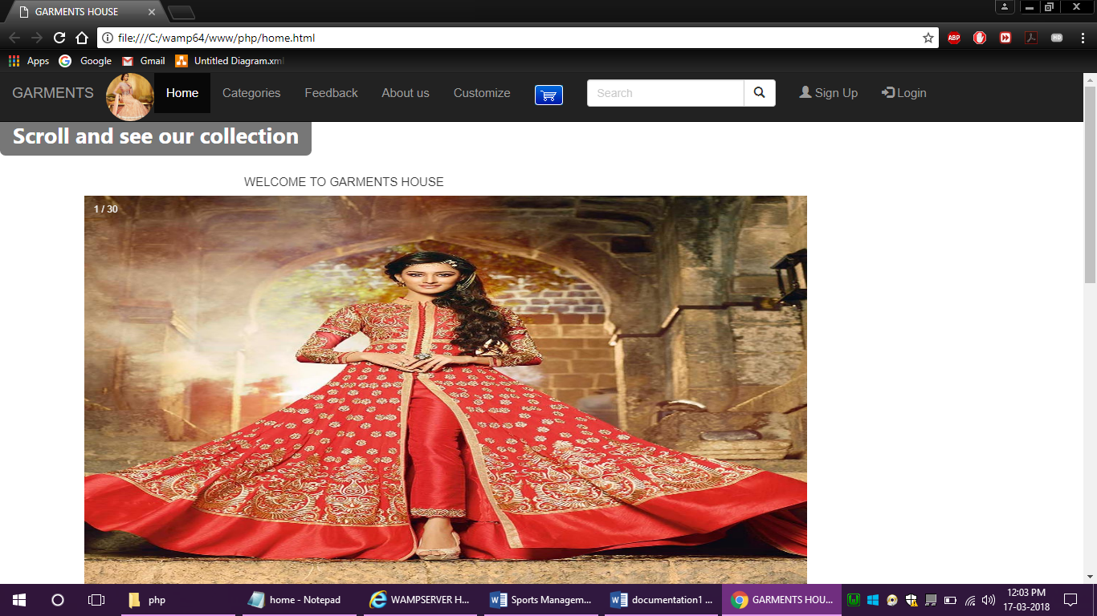

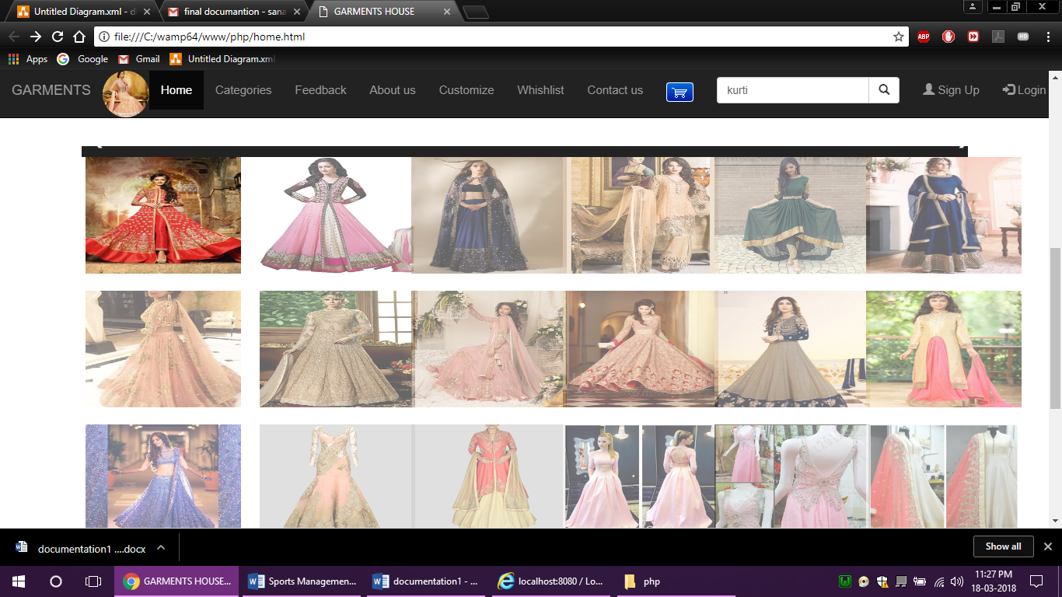

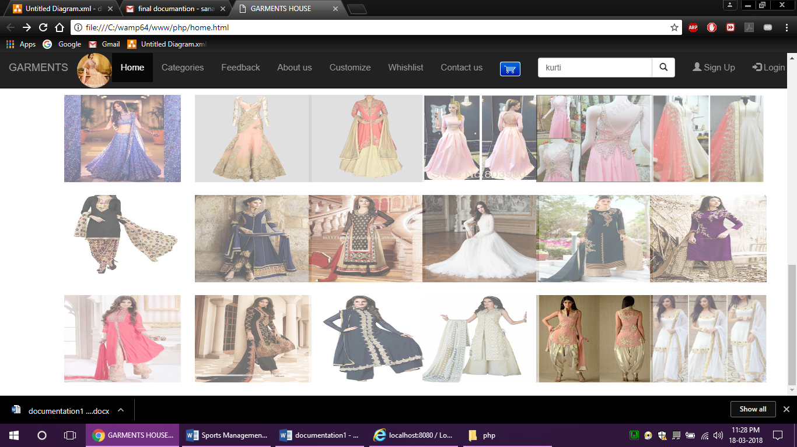

SIGN IN:

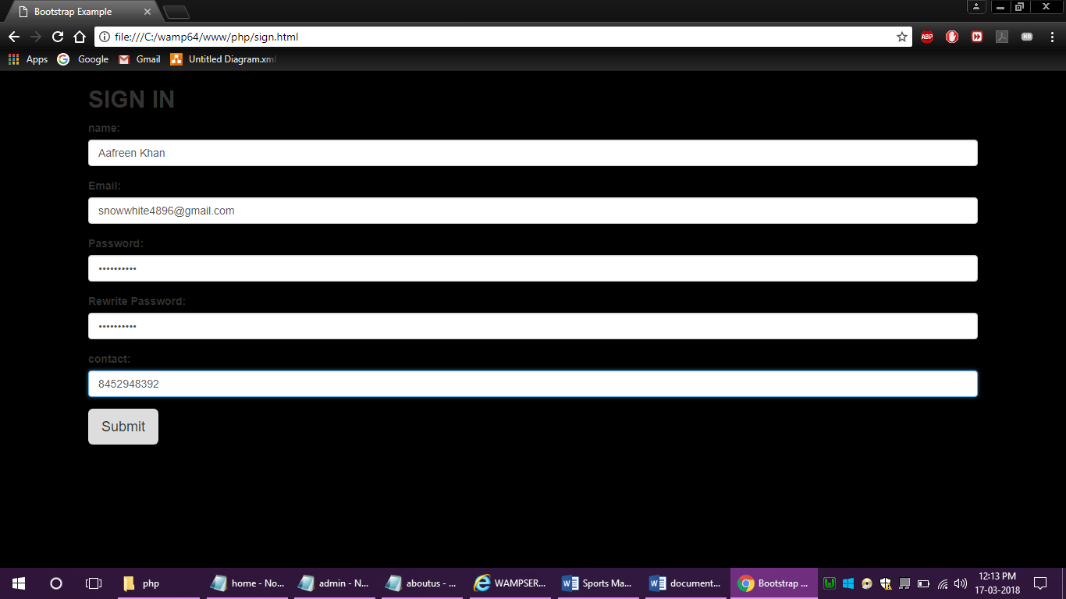

LOG IN:

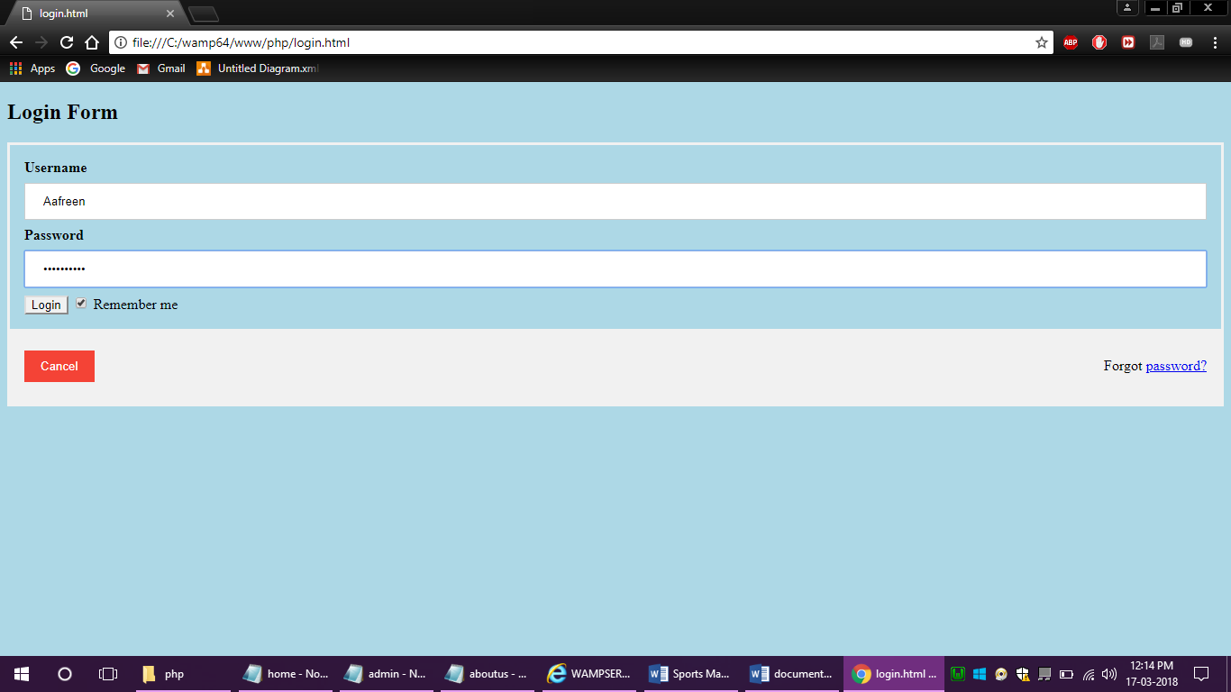

CATEGORIES:

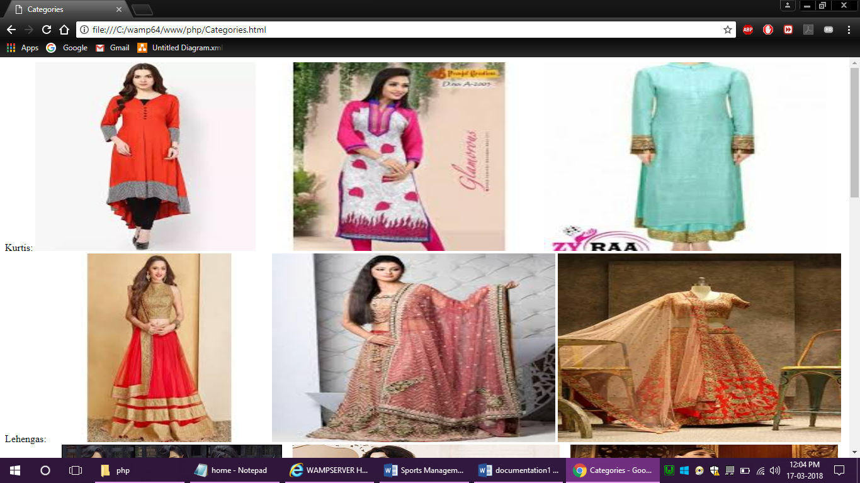

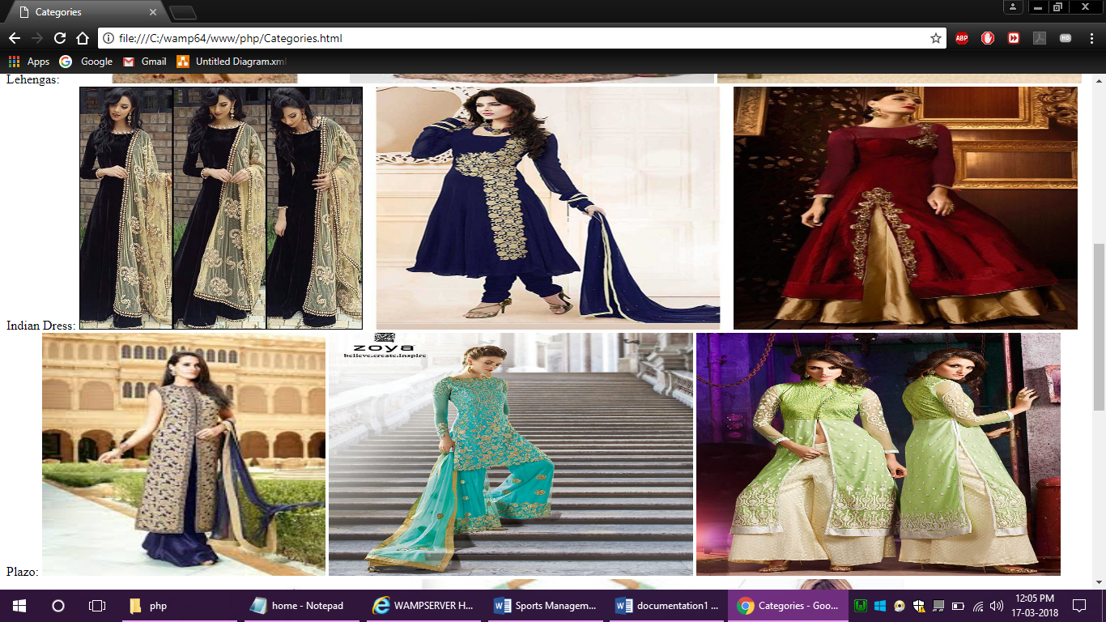

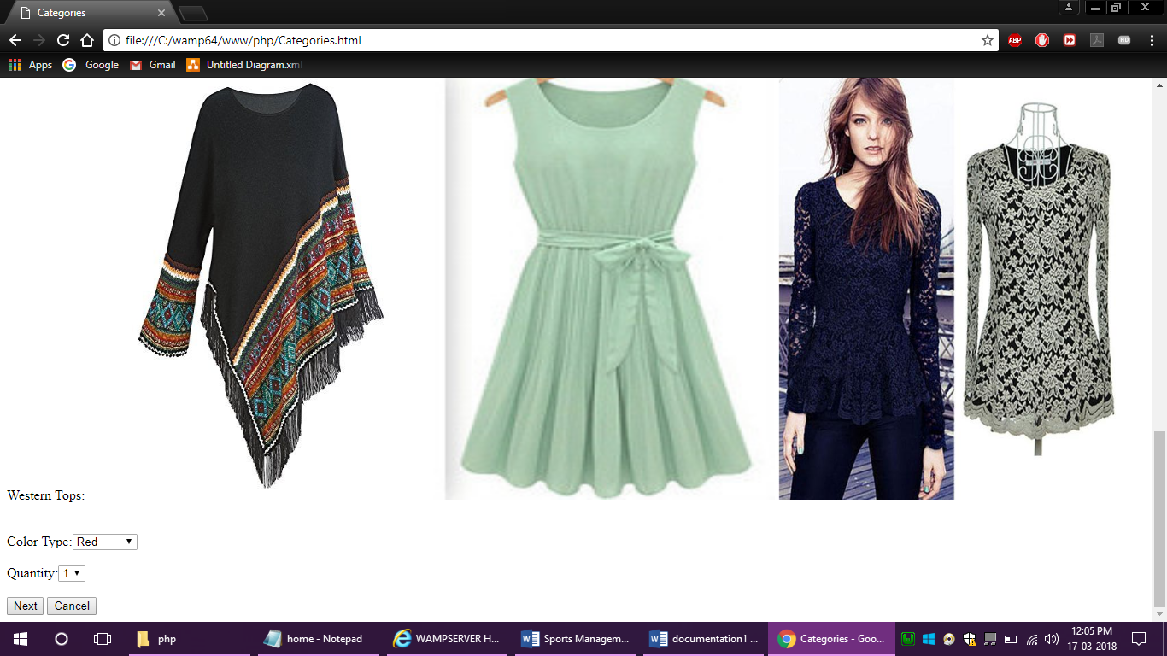

CUSTOMIZE:

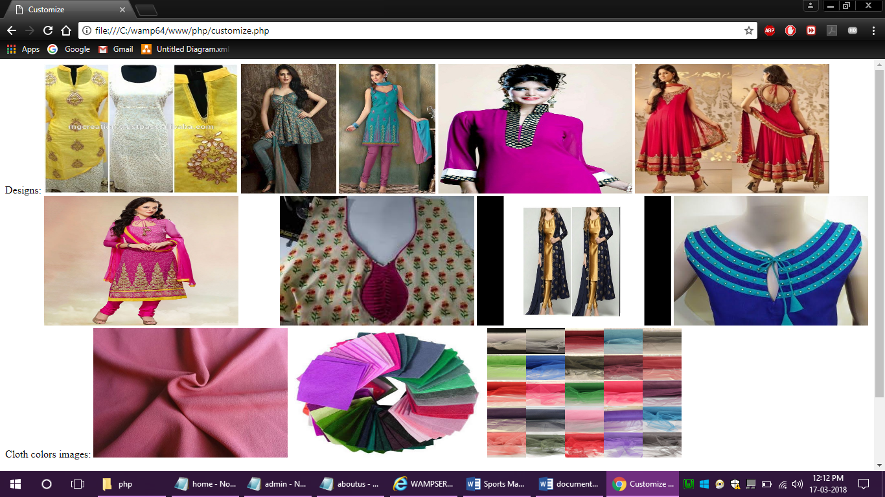

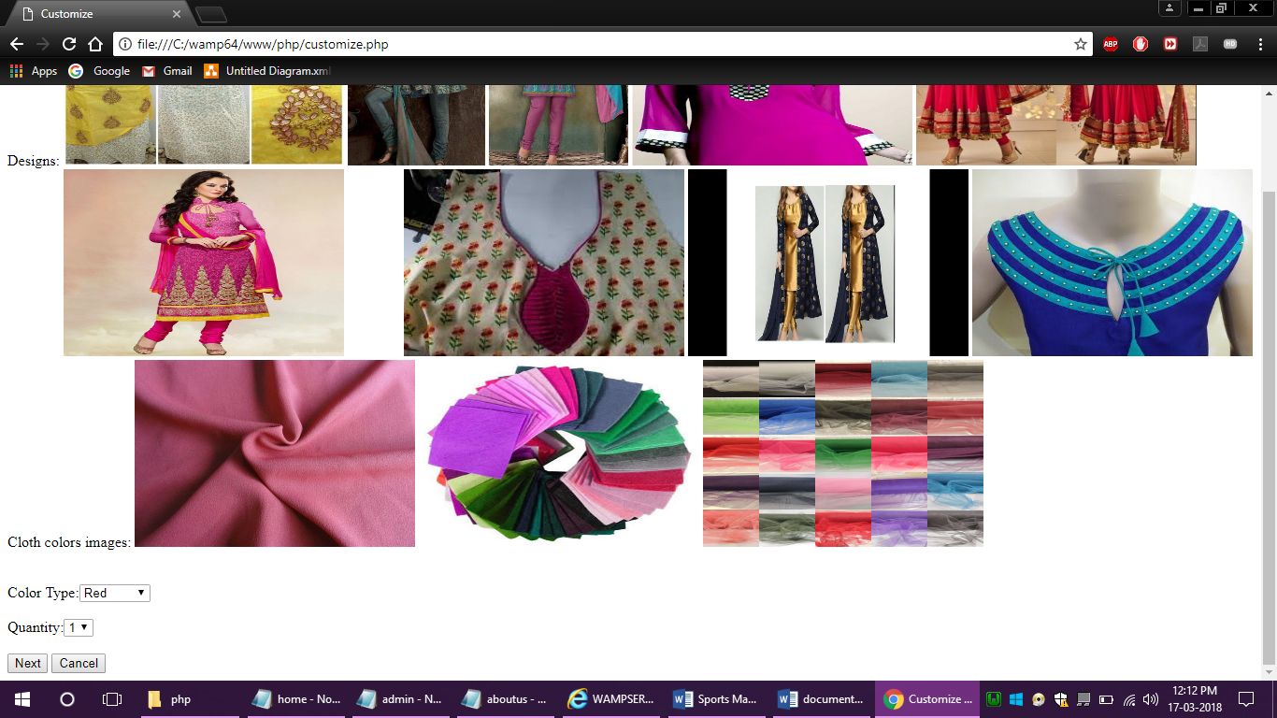

FEEDBACK:

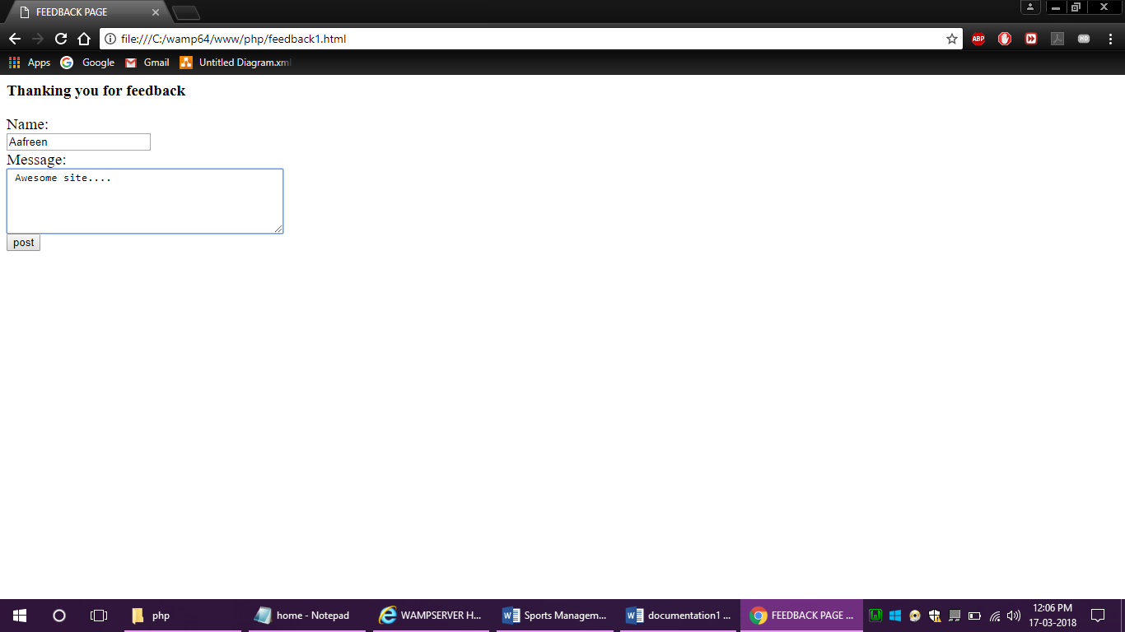

ABOUTUS:

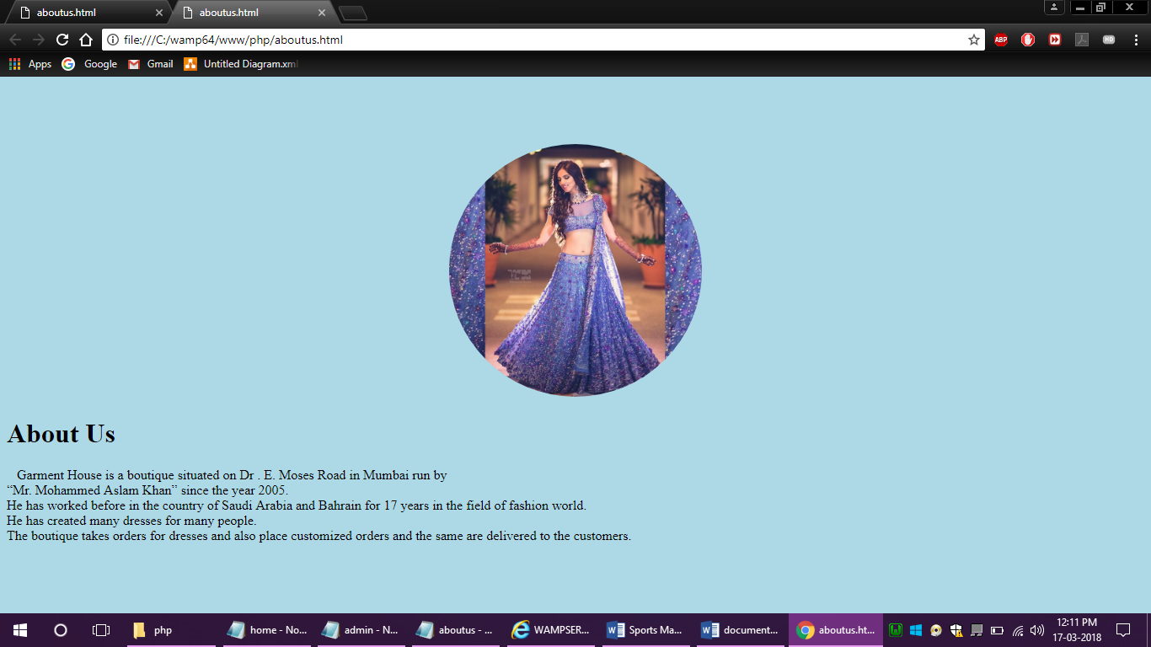

**Program Listing**

|  |
| --- |
| **Pages** |
| index.php |
| register.html |
| login.html |
| categories |
| cusomize |
| wishlist |
| search |
| feedback |
| aboutus |

**SYSTEM IMPLEMENTATION AND UPLOADING**

**SOFTWARE REQUIREMENTS**

|  |  |
| --- | --- |
| **OPERATING SYSTEM** | Microsoft Windows 7 or above |
| **FRONT END** | A web browser |
| **BACK END** | MySQL (5.1+), PHP MyAdmin |
| **WEBSITE** | Wamp Server 3.0 or above |

**HARDWARE REQUIREMENTS**

|  |  |
| --- | --- |
| **MINIMUM REQUIREMENT** | |
| **PROCESSOR** | Intel Pentium IV 2.0 GHz and above |
| **RAM** | 512 MB and above |
| **SCREEN RESOLUTION** | 1024 x 786 display |
| **SUPPORT ARCH** | X86 and X64 |

|  |  |
| --- | --- |
| **RECOMMENDED REQUIREMENT** | |
| **PROCESSOR** | Intel i3 or above |
| **RAM** | **2 GB DDR3 RAM** |
| **SCREEN RESOLUTION** | 1280 x 1024 display |
| **SUPPORT ARCH** | X86 and X64 |

**FUTURE ENHANCEMENT**

The software developed as per of the project further be enhanced as follows:

* Direct access to the developer’s database.
* Take customize order’s.
* Connect database for Garment House app and website.

**Reference and Bibliography**

* www.Getbootstrap.com
* www.W3schools.com
* [www.php.net](http://www.php.net)
* [www.wampserver.com](http://www.wampserver.com)
* www.razorpay.com
* www.https://www.tutorialspoint.com/php